Brynn Rabinowitz
LIS 651-03: Information Professions, Spring 2015
Assignment # 3
What is Library Leadership?
April 27, 2015

I. Problem Statement
Throughout my research, I struggled with finding a conclusive definition of library leadership. Plenty of researchers described the qualities of a library leader. These researchers determined the difference between a library leader and a library manager as well. But none of these researchers defined leadership explicitly.
In this paper, I will attempt to define leadership explicitly. I will include some of the characteristics that I believe truly make a person a leader, and how this is different from a manager. Also, I will discuss the goals a library leader strives to accomplish. Hopefully, by the end of this paper, the definition of a library leader will be clear.
II. Scope
In this project, I will explain the definition of leadership. Next, I will explain the goals of a library leader. Next, I will explain the characteristics of a library leader. Lastly, I will explain the difference between a library leader and a library manager. This will ensure that by the end of this paper, people will understand what being a library leader means, and what they must possess to be considered a library leader and not a library manager.
III. Method
I collected the evidence for this paper through a literature review. I reviewed the ideas of the experts and came up with my own ideas that combine some of the expert opinions that I read.
IV. Findings
- The Definition of Leadership
There is no one definition of leadership. Depending on where one looks, the definition of leadership will change.
Merriam-Webster defines leadership as a person, who leads, or who is in a leadership position (Leadership). Every English teacher, or librarian, knows that a word is never defined using that word. Thus, this definition is not helpful.
There are many quotes about what makes a good leader. For example, Henry Mintzberg explains that leadership is unable to be defined, but is known upon sight (Verzosa, 2009). This sounds like Mr. Mintzberg has given up on his search for a definition of leadership. How can a person only know what a leader is by sight, not through words?
Verzosa defines a leader as “a person who influences a group of people towards the achievement of a goal” (2009). A leader is someone who is able to influence other people to get something accomplished. For example, a library leader might work with a group of people in collection development or fundraising. All librarians must understand fundraising. In order for the goal of growing a collection or raising money to be accomplished, the leader must delegate certain tasks to different people. One person may not be able to complete this goal. With a group of people and a leader to guide them, anything is possible.
A leader is a person that leads silently from the background, and helps other people’s talents to shine. John Quincy Adams explains that a leader is someone whose actions help others to dream, learn, do, and become more then what they believed was possible (Top 10 leadership quotes, 2014). A leader helps other people to realize their potential. For example, if there is someone who is extremely artistic and creative on one’s staff in a library, then a good leader allows that person to create something to showcase this talent. The artist could create an art program for children that includes a short storytime and an art project. At Larchmont Public Library, school-age children are able to participate in a storytime that includes a craft. Children, and parents, love this because they are able to bring a tangible thing home with them to help them remember the story that was read. For example, there is a program coming up that is called “Stories for Mad Scientists: What Hatches?” Children will learn about egg structure and when/how eggs hatch through stories and then create an egg to take home with them (Children’s Programs, 2015). This program is the perfect fit for someone who loves teaching, art projects, and stories. Another example of an artistic program is “Stories and Crafts: Watercolors” (Children’s Programs, 2015). This program allows children to express their own creativity. Thus, your staff member becomes the leader for this program by helping the children develop their own artistic talent. Programs are a great way for leaders to allow their staff to express their individual talents.
Lao Tzu, creator of Daoism, explains that “a leader is best when people barely know he exists, when his work is done, his aim fulfilled, they will say: we did it ourselves” (Famous Leadership Quotes). A leader is a person that lets other people shine. Silent leaders are the best because they help other people to believe in their own power.
According to Patricia Wilson and Josette Lyders, a true leader is someone, who influences others to achieve their goals; builds a team to work towards a shared goal; helps everyone to work together; and influences others to achieve their goals (2001, p.3). This definition combines all of the good qualities from the other definitions. Leaders are team players, who work from the sidelines, and guide other people to find their own success. A leader does not have to be loud. The leader must help other people to achieve their full potential, sometimes without the other person realizing that the leader is even guiding them. Leaders allow their staff to shine and grow on their own. A leader is someone that is known upon sight, but cannot necessarily be described. A leader is a person who helps guide other people to complete shared goals.
- The Goals of a Library Leader
The one goal that is the same for all library leaders and librarians is to promote and keep their library open. Without a library, there can be no library leader.
One goal of library leaders is to make the library a place where people want to work (Bell, 2014). If people do not want to work somewhere, then your library will close. After all, no staff means no library. The library must be a place where people are excited to work (Bell, 2014). Steven Bell believes that the idea of people being excited to come work at their library job is a fantasy. In his article, “Make It a Place They Want to Work,” Steven Bell mentions a 2013 Gallop survey that concludes that 33 percent of people have aspects of their jobs that they enjoy. This is a sad conclusion to come to. Bell believes that this data will help leaders to smarten up and ensure that their places of business or libraries are places that people enjoy working. The more fulfilled people feel at work, the more successful the work will be (Bell).
According to Tony Schwartz, the reason that people are unhappy at work is they feel like they are unable to get work done due to the many distractions that exist in the modern work place. People want to feel like they are accomplishing something at work. If a leader is able to help their employees feel accomplished, then the employees will enjoy their work (Schwartz and Porath, 2014). For example, if a librarian is able to pull off successfully a children’s program, then they will like their work better because they accomplished something of worth. Library leaders need to ensure that they praise their employees when they do a job well done. Thus, their employees will enjoy work. Librarians will be happier if they feel that their work is appreciated. Praising them illustrates this appreciation. Library leaders need to ensure that their employees love working at their library or their library will fail.
Another goal of library leaders is fundraising (Sheldon, 2008, p. 60). All libraries need money. A library leader needs to be able to write grants, and help the library obtain money. Brooke E. Sheldon explains that library leaders must be the ones to fundraise because this activity is too important to delegate (Sheldon, 2008, p. 60). Without money, there can be no library.
According to Brooke E. Sheldon, the main goals of a library leader is to have goals (2008). A goalless leader is unable to direct their team into the future. The library will remain stagnate and disappear with a goalless leader.
A leader can have no more than three or four goals at a time (Sheldon, 2008, p. 60). Too many goals cause a leader to be unfocused. Thus, the leader will be unable to accomplish any goal.
In her article, “Another Look at Leadership,” Brooke E. Sheldon describes the Path-Goal Theory. The Path-Goal theory emphasizes the need for leaders to be able to change their leadership style depending on their desired goal. Sheldon explains that
depending on the situation, the leader can be directive (when the leader knows more about the task than the staff member), participative, that is having staff totally involved in the decision making, or achievement-oriented, that is, challenging staff to perform at the highest possible level (Sheldon, 2008, p. 61)

Leaders need to be directive and give orders to their subordinates. Also, leaders need to be participative, and involve their subordinates in the decision making process. Leaders need to be achievement-oriented, and challenge their subordinates to achieve their best. Leaders need to utilize each of these different styles when necessary to achieve a goal (Sheldon, 2008, p.61).
There are many goals of library leaders. One is to keep the library doors open. Another is to make the library an enjoyable place to work (Bell, 2014). Another goal is fundraising. Another is to have goals, but never more than three or four (Sheldon, 2008, p. 61). A final goal of library leaders is to be able to change their leadership style to suit their desired goals (Sheldon, 2008, p.61). These are some of the many goals of a library leader.
- The Characteristics of a Library Leader
Library leaders embody many characteristics. Researchers discuss many different qualities or characteristics that are necessary for a leader to embody. All researchers and library leaders believe that they know what it takes to be a great library leader. The only problem is, they do not always agree on the qualities/characteristics of a library leader.
Brooke E. Sheldon believes that a leader must be a team player, self-confident, clear and precise, and have perseverance (2008, p.59). Sheldon explains that a leader must be able to work with their employees in developing a vision and goals for the library. If the leader does not work with their staff, then the staff may resent eventually the leader. People like to feel like they have say in what goes on around them. People do not like to be ordered about like children. A good leader must be confident. People will not follow someone, who lacks confidence. If the leader does not believe in themselves, then why should other believe in them? A leader must be able to explain clearly and precisely what must be done and what that leader wishes to accomplish. If the leader cannot explain what must be done, then the staff will not be able to complete the task successfully. Most importantly, a leader must be able to persevere no matter what obstacles stand in his/her way. A good leader will lead a well-run library.
The American Library Association (ALA) has a list of the different physical, emotional, social, intellectual, communication, experience, and trustworthy traits that make a great library leader. In total this is a list of about fifty traits that a person must possess to be considered a library leader. One is skeptical that every library leader possesses all of these traits. In all likelihood, a good library leader must possess some of the traits in each category to be successful. Some examples of library leadership traits are: self-confidence, perseverance, motivational, a great listener, a good communicator, empathetic, able to anticipate challenges prior to their occurrence, energetic, and a risk taker (ALA). If a leader possess these qualities, then they will be able to be successful.
In the article, “Top Ten Traits of Great Library Leaders,” Dr. Steven Matthews describes what he believes are the most important traits of library leaders. The first trait is that leaders are team players (Matthews, 2012). The second trait is that leaders know when to express appreciation to their staff for a job well done (Matthews, 2012). Encouragement is one of the most important qualities that a leader can possess. If a person is encouraged, then they are more likely to do a good job. For example, if a leader knows that someone has a great eye for detail, then the leader can encourage that person to help create a display of books for their library. Thus, the staff member feels like their talents are being recognized and feels good about themselves. The third trait is motivation (Matthews, 2012). A great leader understands how to best motivate each one of their staff. For example, yelling at someone is not a good motivator. A person does not want to be belittled when they are supposed to do something. Inspire someone. Do not make a fool out of them. The fourth trait is the ability to “delegate and empower” their workers (Matthews, 2012). For example, an archivist may not need to possess good customer service skills, but a school library must possess good customer service skills. Know your audience. The fifth trait is an insatiable love of learning (Matthews, 2012). Matthews explains that
the great leader is an active learner, seeking professional development opportunities, listening to people, especially employees, and assimilating knowledge for the purpose of becoming a better decision maker, and a better leader.

A great leader’s job is never done. They must always be willing to learn how to be more. The sixth trait is the ability to problem solve (Matthews, 2012). A leader must be able to solve the problems that are presented to them. The seventh trait is being a great “decision-maker” (Matthews, 2012). If a leader was indecisive, then nothing would get accomplished. The eighth trait is “responsibility” (Matthews, 2012). Without a responsible leader, the entire library crumbles and ceases to exist. The ninth trait is being a “visionary” (Matthews, 2012). If a leader is able to dream and be imaginative about the future of a library, then that library will be successful. As the world becomes more and more digital, libraries must be able to change with the times. A visionary leader is the person that will take the library to the future. The tenth, and final, trait is having a “high character” (Matthews, 2012). A great leader is someone, who does the right thing no matter the consequences, and is generally a good person. People will not follow people that they do not believe in, so a good leader must be able to inspire the people around him/her to believe in therm. These are the ten traits that a great leader must possess.
Different researchers and library leaders believe that a good library leader must possess very different traits. Brooke E. Sheldon, ALA, and Dr. Steven Matthews are just three of the many researchers who study the traits that a leader must possess to be successful.
- Library Leadership vs. Library Management
A library leader is not the same as a library manager. Library managers may possess leadership qualities, but they are not leaders themselves (Sheldon, p.59). A library leader may have some management qualities, but they are not a manager (Sheldon, p.59). Leaders and managers have different outlooks (Sheldon, p.59).
Donald Riggs explains the different traits that a manger and a leader possess:
Manager | Leader
“Administers | Motivates
A copy | An original
Focuses on systems and structure | Focuses on people
Relies on control | Inspires trust
Short-range view | Long-ranger perspective
Asks how and when | Asks what and why
Accepts the status quo | Challenges
Does things right | Does the right thing” (Riggs, 2001, p.6-7)

Managers and leaders have different perspectives on the future. A manager sees only the short term; while a leader sees the big picture and the long term. Leaders and managers ask different questions, rely on different things, and are different types of people. A great leader is rarer than a great manager.
Susan A. Henricks and Genevieve M. Henricks-Lepp did a study of the characteristics of managers and leaders through job advertisements. The following table shows the results of this study:
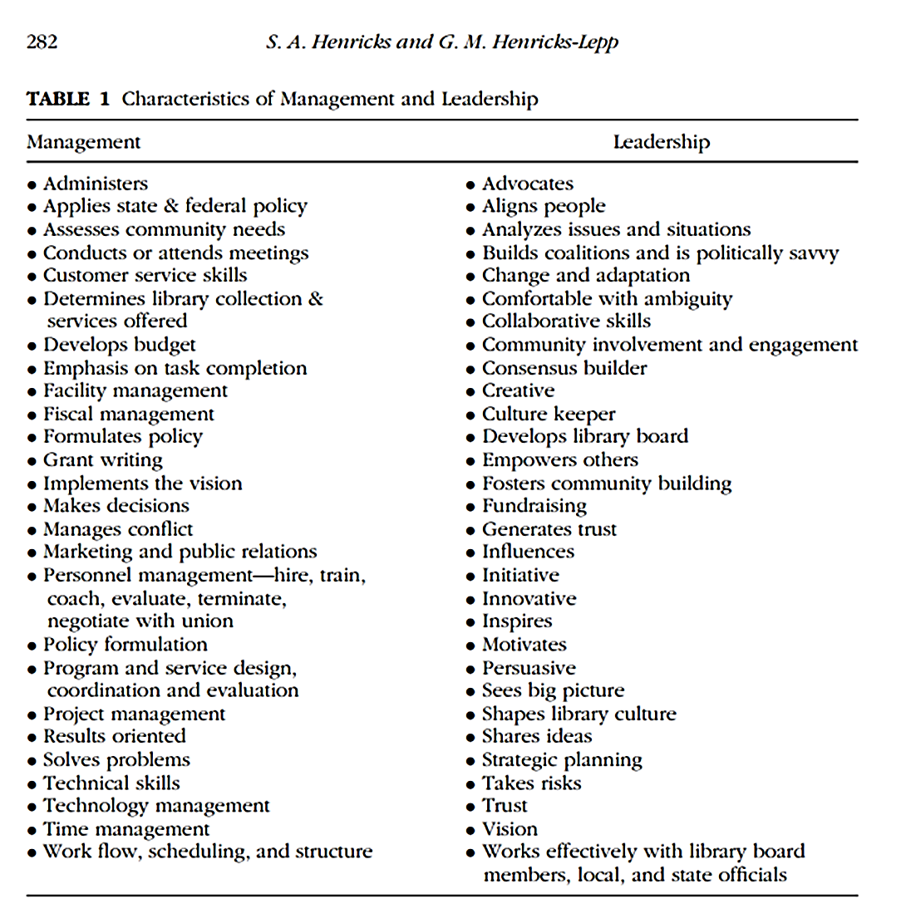
Susan A. Henricks and Genevieve M. Henricks-Lepp found that managers and leaders possess different characteristics. For example, a leader sees the big picture, and shapes the library, while a manager is the person that develops that picture or idea. A manager is the person that is just under a leader, who helps the leader, accomplish their vision. A manager may possess some of the qualities of a leader, but they are not a leader. A true leader is a rare breed.
IV. Conclusion
Lao Tzu, the Chinese philosopher, explains
The leader is best
When people barely know he exists.
Not so good when people obey and acclaim him,
Worse when they despise him.
Fail to honor people, they fail to honor you.
But a good leader, who talks little,
When his work is done, his aim fulfilled, they will say,
‘We did this ourselves.’ (Riggs, 1982, p.12)

A great leader is a person who allows others to shine, who helps others achieve their best. A great leader is someone who is able to attain the best silently from their peers. Libraries need great leaders if they want to continue to thrive in the digital age.
Library leaders must have goals to be successful. Library leaders must fundraise. If there is no money, then there is no library. Library leaders must ensure that their library is a place where people want to work. Library leaders must be able to change their leadership style depending on the goal that they wish to achieve. These are some of the goals that a library leader must accomplish.
Different researchers and library leaders believe that a good library leader must possess very different traits. There are a few traits that researchers agree upon. A great leader must exhibit self-confidence. A great leader must have perseverance. A great leader must be understanding of those around them. A great leader must be able to adapt to the changes that occur around them. A great leader must be a great listener, and be able to influence other people. Leaders must possess these traits to be successful.
A library leader is not the same as a library manager. Library managers may possess leadership qualities, but they are not leaders themselves (Sheldon, 2008, p.59). A library leader may have some management qualities, but they are not a manager (Sheldon, 2008, p.59). Leaders and managers have different outlooks (Sheldon, 2008, p.59). Leaders and managers possess different traits as well. A leader is not a manager.
A library will not run efficiently without the direction of a great leader. In order to know a great leader when one sees them, one must first understand the definition of leadership. One must understand the goals of a good leader. One must understand the characteristics or qualities that a great leader possesses. An understanding of the differences between a leader and a manager is essential as well.

References
American Library Association (ALA). (1996-2015). Leadership Traits. Retrieved April 26,
2015, from http://www.ala.org/nmrt/initiatives/ladders/traits/traits
Bell, S. (2014, June 24). Make It a Place They Want to Work | Leading From the Library.
Retrieved April 25, 2015, from http://lj.libraryjournal.com/2014/06/opinion/leading-from-the-library/make-it-a-place-they-want-to-work-leading-from-the-library/
Children Programs. (2015, Spring). Retrieved April 25, 2015, from
http://www.larchmontlibrary.org/children-programs/
Famous Leadership Quotes. (n.d.). Retrieved April 10, 2015, from
http://www.tumblrquotes.us/famous-leadership-quotes/
Henricks, S., & Henricks-Lepp, G. (2014). Desired Characteristics of Management and
Leadership for Public Library Directors as Expressed in Job Advertisements. Journal of
Library Administration, 54(4), 277-290, DOI: 10.1080/01930826.2014.924310.
Leadership. (n.d.). Retrieved May 10, 2015, from
http://www.merriam-webster.com/dictionary/leadership
Matthews, Dr. S. (2012, December 18). Top Ten Traits of Great Library Leaders. Retrieved
April 26, 2015, from http://21stcenturylibrary.com/2012/12/18/top-ten-traits-of-great-library-leaders/
Riggs, D. (1982). Library Leadership: Visualizing the Future. Phoenix, AZ: Oryx Press.
Riggs, D. (2001). The Crisis and Opportunities in Library Leadership. Journal of Library
Administration, 32(3-4), 5-17, DOI: 10.1300/ J111v32n03_02.
Schwartz, T., & Porath, C. (2014, May 31). Why You Hate Work. Retrieved April 25, 2015,
from http://www.nytimes.com/2014/06/01/opinion/sunday/why-you-hate-work.html?emc=eta1&_r=1
Sheldon, B. (2008). Another Look at Leadership. In K. Haycock & B. Sheldon (Eds.), The
Portable MLIS: Insights from the Experts (pp. 57-64). Westport, CT: Libraries Unlimited.
Top 10 Leadership Quotes That You Need to Know | WCW Partners | SuperSTAR Leadership
Blog. (2014, February 23). Retrieved April 10, 2015, from http://blog.wcwpartners.com/top-10-leadership-quotes-that-you-need-to-know/
Verzosa, F. (2009, May 13). Library Leadership. Retrieved April 10, 2015, from
http://www.slideshare.net/verzosaf/library-leadership
Wilson, P., & Lyders, J. (2001). Leadership for Today's School Library: A Handbook for the
Library Media Specialist and the School Principal. Westport, CT: Greenwood Press.

Henry Mintzberg is an author and academic who has written a lot about management and business ideas. To learn more about him, please visit his website: http://www.mintzberg.org/
I am referencing this from an article that I read. I have a citation for the article not the survey. The survey is mentioned in the article and I was citing the article in this section.
For more information on leadership style see this leadership survey: Alokshri25. (2010, October 10). Leadership Style Questionnaire. Retrieved April 25, 2015, from http://www.scribd.com/doc/39061378/Leadership-Style-Questionnaire This survey can help someone determine their leadership style. This could prove useful when trying to accomplish certain goals because the leadership styles are described in this document as well.
The following are additional resources for library leadership traits/qualities/characteristics: Brey-Casiano, C. (n.d.). Leadership Qualities for Future Library Leaders: Carol's 10 Steps to Being a Great Library Leader. Retrieved April 26, 2015, from http://www.library.illinois.edu/mortenson/book/10_brey-cassiano.pdf Dougherty, R. (2013, March 25). Life Lessons in Library Leadership | Backtalk. Retrieved March 25, 2015, from http://lj.libraryjournal.com/2013/03/opinion/backtalk/life-lessons-in-library-leadership-backtalk/#_ nighhawk309. It's FIRR the better. (2013, May 15). Retrieved April 26, 2015, from http://librarylostfound.com/2013/05/15/its-firr-the-better/ Another great source is http://librarylostfound.com, which is a blog where library leaders share advice for other library leaders.
To read the complete list of leadership traits from the ALA, please visit the following website: http://www.ala.org/nmrt/initiatives/ladders/traits/traits

